[PIONEER](https://www.virtualdj.com/manuals/hardware/pioneer.html) - [DDJ-1000SRT](https://www.virtualdj.com/manuals/hardware/pioneer/ddj1000srt.html) - [LAYOUT](https://www.virtualdj.com/manuals/hardware/pioneer/ddj1000srt/layout.html)

**DECK CONTROLS**

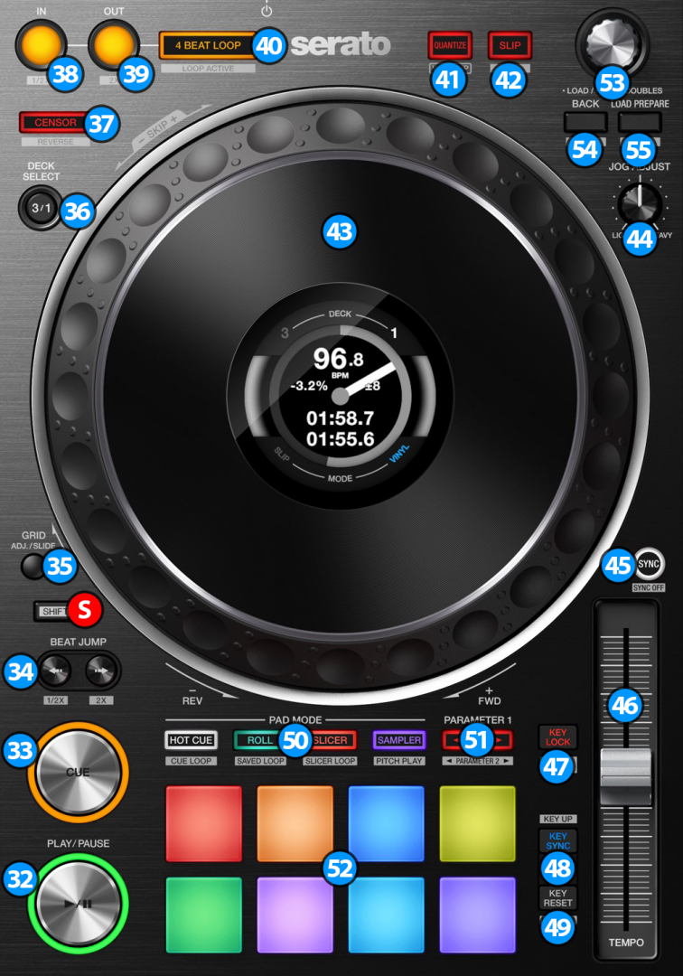

1. **PLAY/PAUSE**. Plays / Pauses the track. Press and hold **SHIFT** and then press this button to "stutter-play" the track from the last set Cue Point.
2. **CUE**. When the Deck is paused, you can set a temporary Cue Point by moving the Platter to place the Audio Pointer at the desired location and then pressing the Cue Button. During playback, you can press the Cue Button to return the track to this Cue Point. (If you did not set a Cue Point, then it will return to the beginning of the track.). If the Deck is paused, you can press and hold the Cue Button to play the track from the Temporary Cue Point. Releasing the Cue Button will return the track to the temporary Cue Point and pause it. To continue playback without returning to the Temporary Cue Point, press and hold the Cue Button, then press and hold the Play Button, and then release both buttons.  
   Hold down **SHIFT** and then press this button to return to the beginning of the track.
3. **BEAT JUMP**: Use these buttons to move track backwards/forward by 4 beats**\***. Keep the buttons pushed for continuous seeking.  
   **\*->** The amount of beats to jump is adjustable. Hold down **SHIFT** and press Jump back button to halve the amount of beats. Hold down **SHIFT** and press the Jump forward button to double the size of beats. Each time the unit gets connected to VirtualDJ the amount of beats will reset back to default 4 beats value.

**S** **SHIFT**. Press and hold this button to access secondary functions (black lettering in gray box) of other controls on the DDJ-1000SRT

1. **GRID ADJUST**: Hold this button pressed and move the **outer** surface of the jog (43) to shift the grid of beats (CBG) of the current track.  
   Hold this button pressed and move the **top** / touch sensitive surface of the jog (43) to adjust the BPM of the current track.
2. **DECK SELECT.** Switch Left decks (1 and 3) and Right Decks (2 and 4).
3. **CENSOR**. Press and hold this button to play the track backwards. On release the track will continue from the position it would have been if the button was never pressed. Hold down **SHIFT** and press this button (momentarily) to play the track backwards. Press again to return to forward direction.
4. **LOOP IN**. Use this button to set a Loop In point (for manual looping).  
   Hold down **SHIFT** and press this button while a loop is active in order to halve the length of the current loop
5. **LOOP OUT**. Use this button to set a Loop Out point (for manual looping).  
   Hold down **SHIFT** and press this button while a loop is active in order to double the length of the current loop.
6. **4 BEAT LOOP**. Use this button to activate an automatic 4 beat loop. If a loop is active use this button to exit the loop  
   Hold down **SHIFT** and press this button to activate a Saved Loop.
7. **QUANTIZE**. Press this button to toggle Quantize on/off. When Quantize is enabled, setting loops, jumping between hot cue points and starting playback of the deck will snap to the grid (CBG) of the track.
8. **SLIP.** Enables Slip Mode. Several software functions (such as Jogwheel movements, HotCues and Loops) will apply temporary on the track, and the track will return to the position it would have been if those functions were not triggered. Hold down **SHIFT** and press this button to toggle between the Scratch and Bend Jogwheel modes.
9. **JOGWHEEL**. Pressure sensitive platter for scratching (Vinyl Mode) or bending (CD Mode).
10. **JOG FEELING ADJUST**. Adjust the tension of the jogwheel (hardware operation)
11. **SYNC**. Press this button to automatically match the corresponding Deck's tempo with the opposite Deck's (or the Master Deck’s if using a 4 decks Skin) tempo and phase. Hold down **SHIFT** and press this button to reset the tempo of the track back to it's original value.
12. **TEMPO**. Controls the track's playback tempo.
13. **KEY LOCK**. Press this button to "lock" the track's pitch to its original key. The track's tempo will remain at the speed designated by the Pitch Fader. Hold down **SHIFT** and press this button to cycle through the available pitch ranges (8%, 16%, and 50%)
14. **KEY SYNC**. Press this button to match the musical Key of the track with the Key of the Master deck (or the other deck if using a 2 decks skin). The change of the Key will be the smallest required to make it compatible with the other Key. Hold down **SHIFT** and press this button to increase the key of the track by one semitone.
15. **KEY RESET**. Press this button to reset the musical Key of the track to it's original value. Hold down **SHIFT** and press this button to decrease the key of the track by one semitone.
16. **PAD MODE**. Switch the pads of the unit to various modes (see [PADS](https://www.virtualdj.com/manuals/hardware/pioneer/ddj1000srt/layout/pads.html))
17. **PAGE/PARAMETERS**. Offer various operations, depending on the PADs Mode (see [PADS](https://www.virtualdj.com/manuals/hardware/pioneer/ddj1000srt/layout/pads.html))
18. **PADS**. Offer various operations, depending on the PADs Mode (see [PADS](https://www.virtualdj.com/manuals/hardware/pioneer/ddj1000srt/layout/pads.html))

**[BROWSER CONTROLS](https://www.virtualdj.com/manuals/hardware/pioneer/ddj1000srt/layout/decks.html" \l "browser)**

1. **BROWSE**.  
   **Turn:** Scrolls through files or folders.  
   **Push**: If focus is on the Folders list press the knob to set focus on the Songs list. If focus is on the Songs list, press once to load the selected track on the deck, or press twice (double-click) to clone the track from the other deck to this deck.  
   Hold down **SHIFT** and press the knob down to display the VirtualDJ Browser in zoom state.
2. **BACK**. Press this button to set focus to the Folders list. If focus is on Folders list, use this button to expand/collapse sub-folders.  
   Hold down **SHIFT** and press this button to add the selected track on the current playlist.
3. **LOAD PREPARE.**. Press this button to set focus to the Sideview list. If focus is on Sideview list, press this button to set focus back to Songs list.  
   Hold down this button for one second to show/hide the track info panel.  
   Hold down **SHIFT** and press this button to cycle though the available Sideview lists (Automix, Sidelist, Karaoke, Sampler and Clone).

**[ON JOG DISPLAY](https://www.virtualdj.com/manuals/hardware/pioneer/ddj1000srt/layout/decks.html" \l "jogdisplay)**

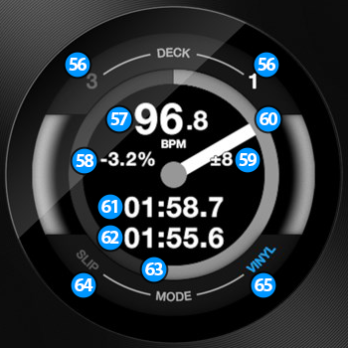

1. **DECK**. Shows the current deck assignment for the deck controls.
2. **CURRENT BPM**. Shows the current BPM (Beats Per Minute) of the track.
3. **PITCH ADJUSTMENT**. Shows the current pitch adjustment of the track.
4. **PITCH RANGE**. Shows the pitch range that can be used by the Tempo Slider.
5. **JOG ROTATION STICKER**. Shows the rotation of the jog.
6. **ELAPSED TIME**. Shows the elapsed time of the track.
7. **REMAINING TIME**. Shows the remaining time of the track.
8. **TRACK PROGRESS**. Shows the overall track progress.
9. **SLIP**. Turns on when slip mode is active
10. **VINYL**. Turns on when vinyl mode is active.

[PIONEER](https://www.virtualdj.com/manuals/hardware/pioneer.html) - [DDJ-1000SRT](https://www.virtualdj.com/manuals/hardware/pioneer/ddj1000srt.html) - [LAYOUT](https://www.virtualdj.com/manuals/hardware/pioneer/ddj1000srt/layout.html)

**MIXER & EFFECTS**

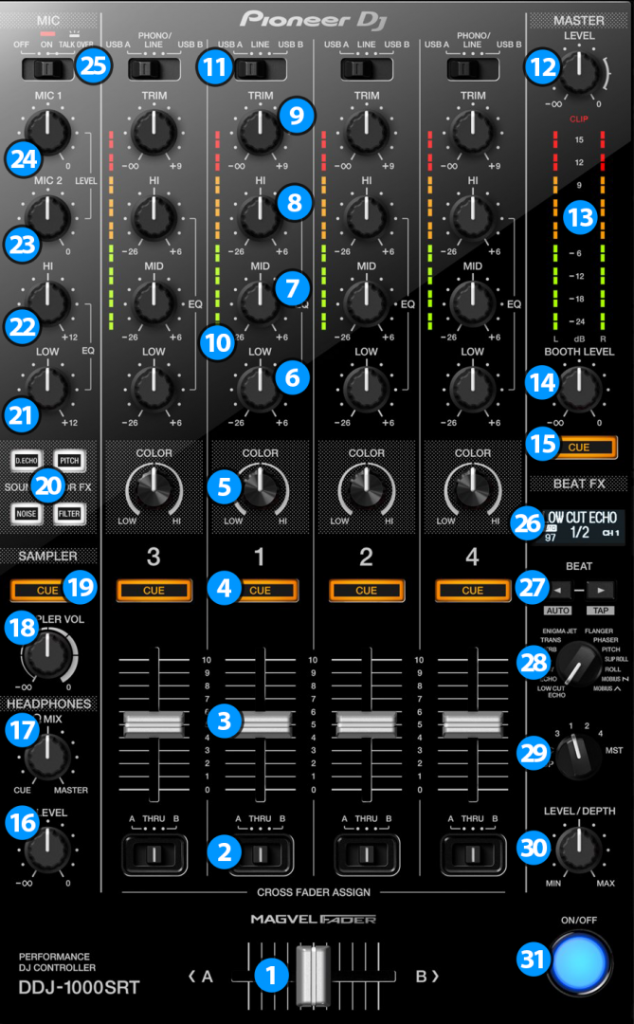

**[MIXER CONTROLS](https://www.virtualdj.com/manuals/hardware/pioneer/ddj1000srt/layout/mixer.html" \l "mixer)**

1. **CROSSFADER**. Blends audio between the channels assigned to the left and right side of the crossfader.
2. **CROSSFADER CH ASSIGN**. Define if a mixer channel will be output regardless of the position of the crossfader (THRU position) or Left/Right.
3. **VOLUME**. Adjust the Volume of each channel. While **SHIFT** is held down, the VOLUME faders will stop the deck at the previously selected Cue when these reach the minimum level (zero) and will start the deck (synced to the other deck) if those move from the zero position. (Fader Start)
4. **CUE (PFL)** (per channel) Press these buttons to send each channel to the Headphones Output channel.
5. **COLOR FX PARAMETER**. Adjust the parameter of the selected COLOR FX for each channel. When in middle position, the COLOR FX has no effect on the sound.
6. **LOW EQ**. Adjust the Low frequencies for each mixer channel.
7. **MID EQ**. Adjust the Mid frequencies for each mixer channel.
8. **HI EQ**. Adjust the High frequencies for each mixer channel.
9. **TRIM**. Adjust the Gain of each mixer channel.
10. **CH INPUT VUMETER**. Shows each channels input (pre fader) volume.
11. **INPUT SELECTORS**. Define the source of each Channel. Put the switchers to **USB A** or **USB B** position for software mixing.
12. **MASTER VOLUME**. Adjust the level of the Master Output.
13. **MASTER OUTPUT VUMETER**. Shows the master output volume of the unit.
14. **BOOTH MONITOR**. Adjust the level of the Booth Output of the DDJ-1000SRT.
15. **MASTER CUE (PFL)**. Send the Master Output of the unit to the Headphones Output channel. Please note that in order to hear the Master Output on your headphones you must also turn the **HEADPHONES MIXING (17)** knob to the desired position.
16. **HEADPHONES VOLUME.** Adjust the volume of the Headphones Channel.
17. **HEADPHONES MIXING.** Adjust how the Channels and the Master Output blend at the Headphones Channel.
18. **SAMPLER VOLUME**. Adjust the Master Output Volume of the VirtualDJ Sampler
19. **SAMPLER PFL**. Send the sound of VirtualDJ Sampler to the Headphones Output channel.
20. **SOUND COLOR FX**. Select one of the predefined Color Effects (Dub Echo, Pitch, Noise and Filter).
21. **MIC LOW EQ.** Adjust the Low frequencies of MIC1 and MIC2 Inputs of the DDJ-1000SRT
22. **MIC HI EQ.** Adjust the High frequencies of MIC1 and MIC2 Inputs of the DDJ-1000SRT
23. **MIC 2 VOLUME.** Adjust the Volume Level of MIC2 Input of the DDJ-1000SRT
24. **MIC 1 VOLUME.** Adjust the Volume Level of MIC1 Input of the DDJ-1000SRT
25. **MIC CONTROL.** Turn ON and OFF the MIC1 and MIC2 Inputs of the DDJ-1000SRT or enable the auto Talk Over.

Please note that all mixer operations are **hardware** controlled, but their movement is visible in VirtualDJ GUI

**[EFFECT CONTROLS](https://www.virtualdj.com/manuals/hardware/pioneer/ddj1000srt/layout/mixer.html" \l "effects)**

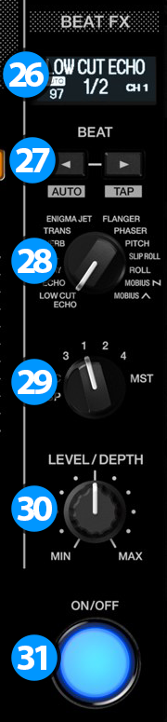The BEAT FX section is used to apply **hardware** effects to Decks, Master, Mic or Sampler.

1. **BEAT FX LCD SCREEN:** Shows information about the selected effect.
2. **BEAT**: Use these buttons to half/double the Beats Parameter of the selected Effect (for the Effects that are beat-aware). The beats value is displayed on the LCD screen.
3. **BEAT FX SELECT**: Use this selector knob to select one of the available Beat FX. The name of the selected Effect is displayed on the LCD screen.
4. **BEAT FX ASSIGN**: Use this selector knob to select to which source the effect will apply to. (Decks, Master, Mic or Sampler). The selected source will be displayed on the LCD screen.
5. **BEAT FX LEVEL**: Use this knob to adjust the 1st Parameter of the selected Effect.
6. **BEAT FX ON**: Use button to enable/disable the selected Beat FX. Its led will flash when enabled

[PIONEER](https://www.virtualdj.com/manuals/hardware/pioneer.html) - [DDJ-1000SRT](https://www.virtualdj.com/manuals/hardware/pioneer/ddj1000srt.html) - [LAYOUT](https://www.virtualdj.com/manuals/hardware/pioneer/ddj1000srt/layout.html)

**PERFORMANCE PADS**

The 8 Pads offer various functions, depending on the selected Pad mode. Each of the 4 Pad mode buttons offers 2 individual modes. One with the press of the mode button, and an additional mode with press of the mode button while **SHIFT** is held down. The 8 modes represent a page of the PADS section on the default VirtualDJ GUI.

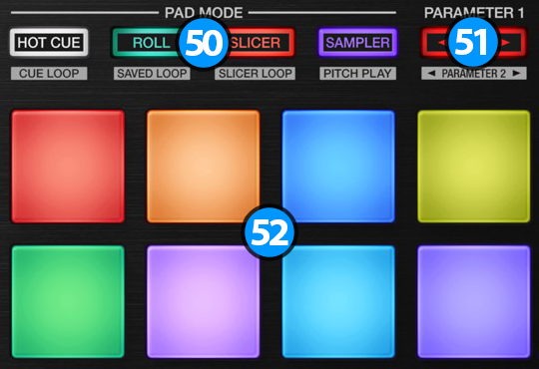

1. **PAD MODE**. Press any of the 4 available Pad mode buttons to set the Pads to Hotcues, Loop Roll, Slicer and Sampler mode.  
   Hold **SHIFT** and then press any of the 4 available Pad mode buttons to set the Pads to Cue Loop, Saved Loops, Scratch and Keycue mode.
2. **PADS**. The 8 Pads offer different functionality depending on the selected mode.
3. **PARAMETERS**. Depending on the selected page, these buttons control various parameters of the selected page.

**[HOTCUES](https://www.virtualdj.com/manuals/hardware/pioneer/ddj1000srt/layout/pads.html" \l "hotcues)**

Press the **HOT CUE** mode button to set the PADs to Hot Cue mode (button will be lit white) and automatically load the Hotcues pads page in VirtualDJ GUI  
  
Each one of the 8 pads **assigns a Hot Cue Point, or jumps** the track to that Hot Cue Point (if assigned).  
When a Hot Cue Button is unlit, you can assign a Hot Cue Point by pressing it at the desired point in your track. Once it is assigned, the Hot Cue Button will light on.  
  
Hold **SHIFT** and then press a pad to **delete** its assigned Hot Cue Point.  
Press the **PARAMETERS** buttons to jump to previous/next cue point in the track (if it exists)

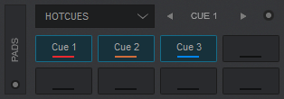

*Hotcues Pads Page – VirtualDJ GUI, PRO Layout*

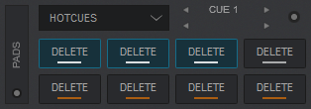

*Hotcues Pads Page while SHIFT is held down – VirtualDJ GUI, PRO Layout*

**[LOOP ROLL](https://www.virtualdj.com/manuals/hardware/pioneer/ddj1000srt/layout/pads.html" \l "looproll)**

Press the **ROLL** mode button to set the PADs to LOOP ROLL mode (button will be lit green) and automatically load the LOOP ROLL page in VirtualDJ GUI.  
  
Press one of the 8 pads to trigger a **momentary** Loop Roll. Once the Pad is released, the track will resume playing from the position it would have been if the Loop Roll was never triggered. The exit point will be visible on the waveform of the VirtualDJ GUI with an additional “running” play marker.  
  
Hold **SHIFT** to get ½, ¾, 1 and 2 beats Loop Roll sizes for the 4 lower pads.  
Use the Page menu to apply the Loop Rolls to Video.  
  
The **PARAMETER** buttons are not used in this mode.

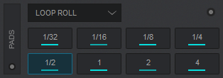

*Loop Roll Pads Page – VirtualDJ GUI, PRO Layout*

**[SLICER](https://www.virtualdj.com/manuals/hardware/pioneer/ddj1000srt/layout/pads.html" \l "slicer)**

Press the **SLICER** mode button to set the PADs to Slicer mode (button will be lit red) and automatically load the Slicer Pads page in VirtualDJ GUI  
  
The 8 pads represent eight sequential beats—"Slices"—in the Beat Grid. The currently playing Slice is represented by the currently green lit pad. The light will move through the pads as it progresses through each eight-Slice phrase. Press a pad to repeat that Slice (hold it down if you want to keep looping it).  
Once the Pad is released the track will continue to play from the position it would have been if the pad was never pressed.  
  
Hold **SHIFT** and then use the Pads to repeat the memorized Slices (the Slices played/repeated last time)  
  
Use the **PARAMETER** buttons to adjust the length of the Loop applied to the slice.  
Hold **SHIFT** down and then use the **PARAMETER** buttons to adjust the step of the Slices

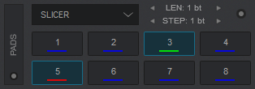

*Slicer Pads Page - VirtualDJ GUI, PRO Layout*

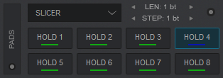

*Slicer Pads Page while SHIFT is held down - VirtualDJ GUI, PRO Layout*

**[SAMPLER](https://www.virtualdj.com/manuals/hardware/pioneer/ddj1000srt/layout/pads.html" \l "sampler)**

Press the **SAMPLER** mode button to set the PADs to Sampler mode (button will be lit purple) and automatically load the Sampler Pads page in VirtualDJ GUI  
  
Each one of the 8 pads **triggers a sample** from the selected Sampler Bank of VirtualDJ. If a bank has less than 9 samples, both sides of the DDJ-1000SRT will control the same samples. If a bank has more than 8 samples, the left side of the DDJ-1000SRT will control samples 1 to 8 and the right side samples 9 to 16.  
Press the pads to trigger a sample. Depending on the selected trigger Pad mode, use **SHIFT** and the same pads to **stop**the sample.  
Use **PARAMETER** buttons to select the **Sampler Bank** (previous/next).

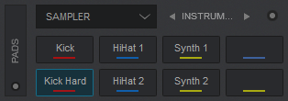

*Sampler Pads Page – VirtualDJ GUI, PRO Layout*

**[CUE LOOP](https://www.virtualdj.com/manuals/hardware/pioneer/ddj1000srt/layout/pads.html" \l "cueloop)**

Hold down **SHIFT** and press the **HOT CUE** mode button to set the PADs to Cue Loop mode (button will be lit blue) and automatically load the Cue Loop Pads page in VirtualDJ GUI  
  
In this mode each one of the 8 pads assigns a Hot Cue Point or jumps the track to that Hot Cue Point, but in both cases, **it also triggers a Loop** at that point (momentary or toggle depending on the selected mode from the Page menu).  
  
Hold **SHIFT** and then press a pad to stutter/jump to the Hotcue (loop will remain triggered)  
  
Use **PARAMETER** buttons to half/double the size of the triggered Loop.  
Hold **SHIFT** and then use **PARAMETER** buttons to select the On/Off (Toggle) or Hold (momentary) Loop trigger mode.

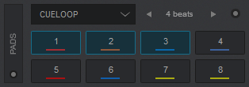

*Cue Loop Pads Page – VirtualDJ GUI, PRO Layout*

**[SAVED LOOPS](https://www.virtualdj.com/manuals/hardware/pioneer/ddj1000srt/layout/pads.html" \l "savedloops)**

Hold down **SHIFT** and press the **ROLL** mode button to set the PADs to Saved Loops mode (button will be lit orange) and automatically load the SAVED LOOPS page in VirtualDJ GUI.  
  
Each one of the 8 pad represents a slot to save and recall a loop.  
Press a Pad to **save** (and trigger at the same time - if not already) a Loop at the current position.  
**Hold** the same Pad down for more than 2 seconds to **delete** the saved loop from the slot.  
When a Loop is saved to a slot, use the same Pad to **load\*** (enable) the saved loop, but not jump to its position if the loop is saved to a later position than the current one (loop load and prepare).  
Hold **SHIFT** and then use the same Pad to **load\*** (enable) the saved loop, **and jump** to its position.  
  
\*Note that only 1 Loop can be enabled each time.  
  
Use the **PARAMETER** buttons to half/double the size of the Loop.  
Hold **SHIFT** and then use the **PARAMETER** buttons to move the Loop back/forth in time by 1 beat steps.

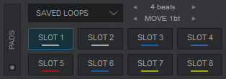

*Saved Loop Pads Page – VirtualDJ GUI, PRO Layout*

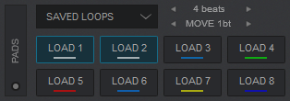

*Saved Loops Pads Page while SHIFT is held down – VirtualDJ GUI, PRO Layout*

**[SCRATCH](https://www.virtualdj.com/manuals/hardware/pioneer/ddj1000srt/layout/pads.html" \l "scratch)**

Hold down **SHIFT** and press the **SLICER** mode button to set the PADs to Scratch mode (button will be lit cyan) and automatically load the Scratch Pads page in VirtualDJ GUI  
  
In this mode, each one of the 8 Pads performs a different **Scratch routine**  
  
The **PARAMETER** buttons are not used in this mode.

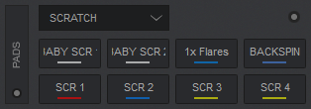

*Scratch Pads Page – VirtualDJ GUI, PRO Layout*

**[KEY CUE](https://www.virtualdj.com/manuals/hardware/pioneer/ddj1000srt/layout/pads.html" \l "keycue)**

Hold down **SHIFT** and press the **SAMPLER** mode button to set the PADs to KeyCue mode (button will be lit green) and automatically load the KeyCue Pads page in VirtualDJ GUI  
  
In this mode, the Pads trigger a selected Hotcue point (or the Temporary Cue if none selected or not available) at a selected Key semitone (from -7 to +7).  
8 different pages/banks are offered with various semitone values to use and a 0 value (reset key to it's original value) is always offered in all pages.  
Hold **SHIFT** and then **select a Hotcue** for the Key pads to trigger. Each time a Pad is pressed, the track will jump to that Hotcue point and will also alter the Key of the track to the value designated by it assigned value.  
  
Use the **PARAMETER** buttons to **adjust the Key** of the track without trigger a Hotcue.  
Hold down **SHIFT** and use the **PARAMETERS** buttons to select a different **bank** with different key semitone values.

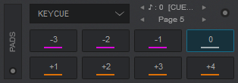

*KeyCue Page - VirtualDJ GUI - PRO Layout*

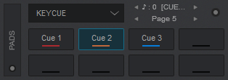

*KeyCue Page while SHIFT is held down - VirtualDJ GUI, PRO Layout*

Read further details about Pads in the [VirtualDJ 2020 manual](https://www.virtualdj.com/manuals/virtualdj8/interface/decks/decksadvanced/pads/index.html" \t "_blank)